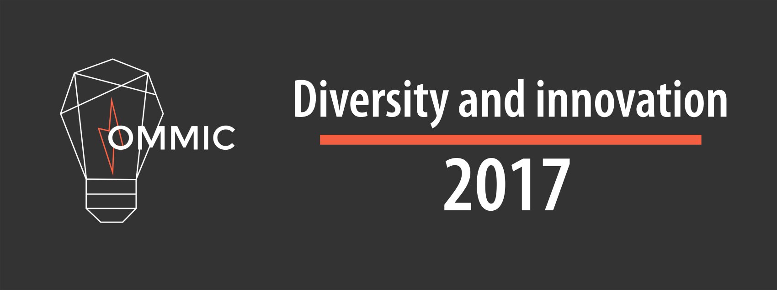

Hello Rick

Thank you so much for applying to be a speaker at OMMIC 2017. We would like to formally invite you to speak at our conference.

We are trying to keep the website up to date. We would like to post a picture of you along with a short bio. This way participants can learn about your talk as well as who you are. If you could send us a picture and a short bio (~200 words), we will add it to the site! Feel free to add your Twitter handle, Instagram account, or any other social media site you want to brag about.

**Here is some key information pertaining to your talk**

* Expect approximately 15-20 people
* It should last approximately 1 hour
* At the beginning, you will be introduced by a member of the Ommic staff. If you would like us to say something specific, let us know

We would like to learn a little bit more about your talk **Hands-on Coding robot as a gateway to At-Risk-Youth.** We have two types of locations for our speakers. Either a presentation room, where there is a projector and podium or a workshop room which also has a projector, but is more conducive to hands on workshops. From the description you provided, a workshop room would be best for you talk. Is this correct? Do you require any other equipment (Computers, soldering irons, 3d printers, etc.)?

We will be contacting you shortly with the date and time for your talk.

If you have any other questions, please to do not hesitate to contact us.

Thank you

Danielle

OMMIC Organizer

Ommic 2017: Diversity and Innovation

Ommic.ca

|  |  |  |  |
| --- | --- | --- | --- |
| Andrew McDonald | Mentor Stream: talks about educating, teaching, and inspiring, Skill building: Hands-on workshops that teach or show off a skill | Starting from Scratch with Scratch | Kids Code Jeunesse is a national non-profit looking to empower students and teachers to learn and create with code. I will introduce Scratch and some basic programming concepts that can be used. Scratch is a block based programming language that can be used from K-12 in all fields of study. |
| Jennie Brown | Skill building: Hands-on workshops that teach or show off a skill | Getting started with Dash and Dot | Students will be introduced to coding with Dash and Dot. These primary / junior friendly robots can move, make sound and use sensors. There are several apps such as Go, Blockly and Xylo that students will be introduced to. Students will learn how to use the apps to program their robot and complete a number of challenges. |